**Programming for Computer Games - Home Assignment**

**Timothy John Xuereb – 4.2B**

Question 1a:

**Unity & Construct**:

The advantageous features of using Unity are:

* Easy to use
* Available for almost any current generation platform
* Collision Detection
* Asset Tracking

Question 1b:

**JavaScript & C#:**

The advantageous features of using C#:

* Structural Support
* More efficient performance wise
* Great Debug integration
* Used in most Unity projects

Question 2a:

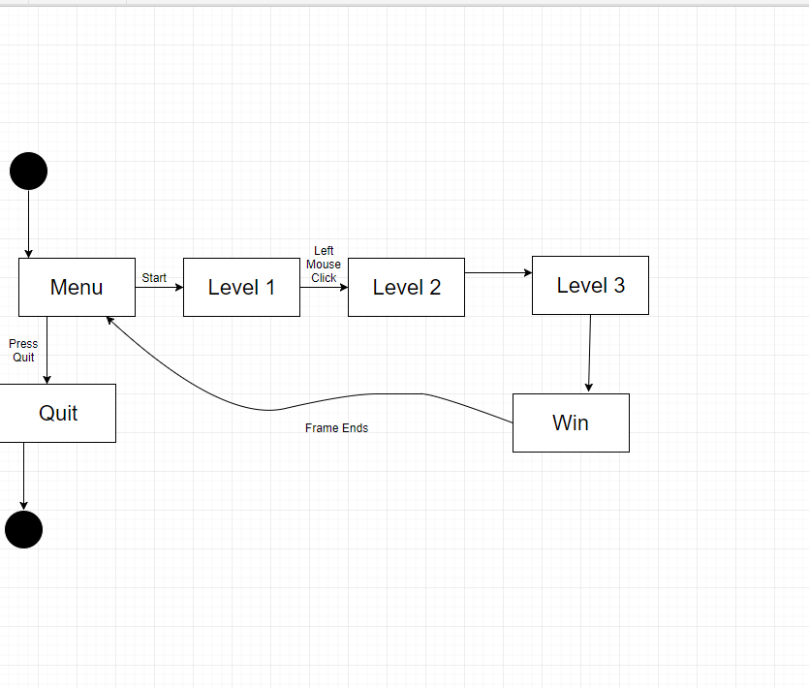

Question 2b:

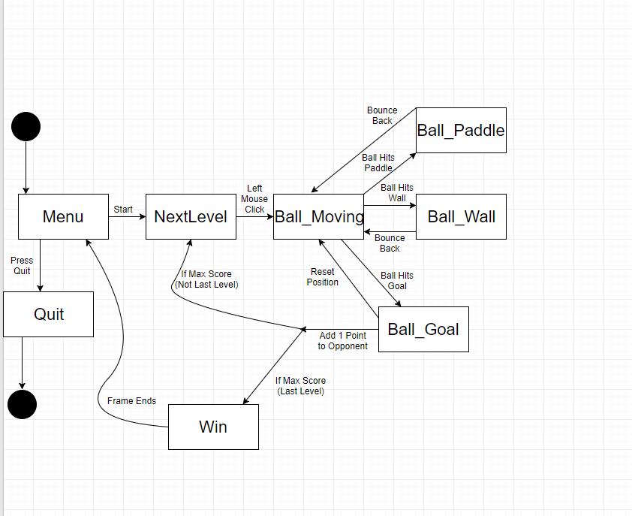

Question 3:

Compressing media assets is proven valuable since the game in its entirety already boasts a large amount of space on its own. So by compressing images, videos and audio, you will be removing redundant bits of data off files and shrinking the whole project in size. An example of why this is important is due to certain mobile devices or even application stores impose a size limit. **See below for picture referrence.**

